Question #1

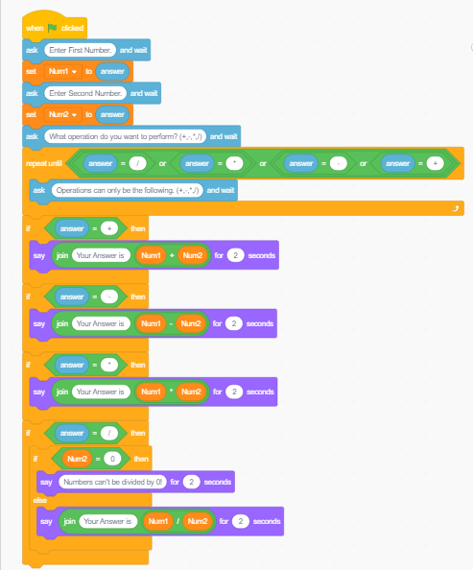

Question #2

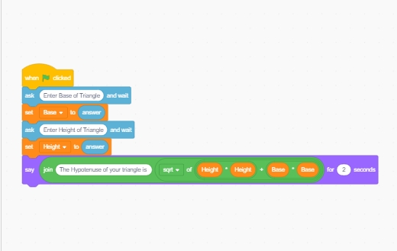

Question #3

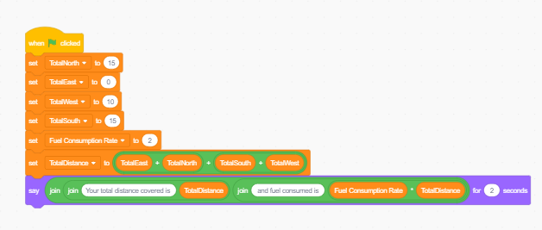

Question #4

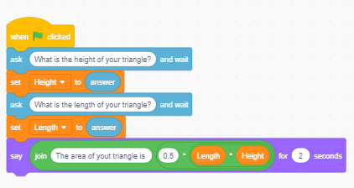

Question #5

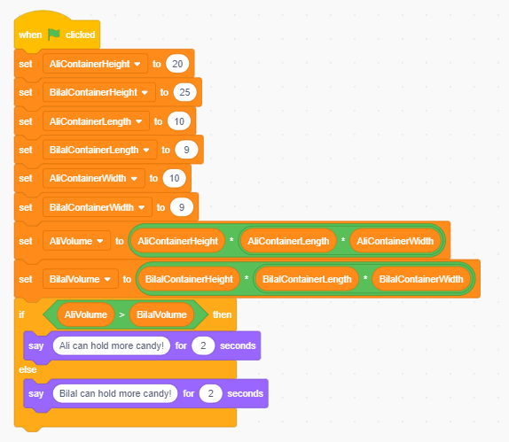

Question #6

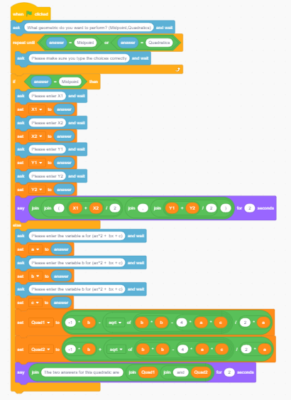

This is just written in case you can’t understand what is shown in the picture above.

* Ask the user which geometric function they want to perform?
* Validate the user’s answer to only be midpoint or quadratic as there is no other function available
* If user chose midpoint then ask to enter X1 , X2 , Y1 , Y2
* Then calculate the midpoint using the formula given
* Since user can only choose between Midpoint and Quadratics if he didn’t choose idpoint he could have only chosen Quadratics , therefore we used “IF…THEN…ELSE”
* For Quadratics ask the user to enter “a , b , c”
* Then calculate the value of x using the formula given

Question #7

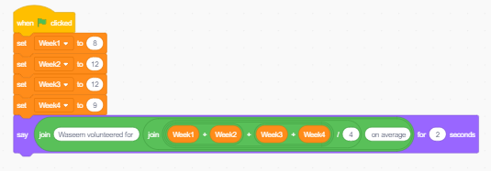

Question #8

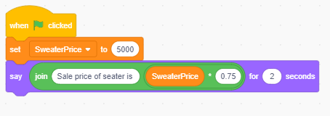

Question #9

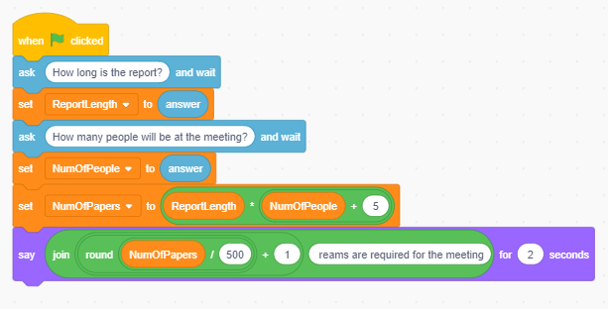

*I have also sent the Scratch Files if you need to understand the codes in further detail.*

**Thank you!**